**Central Tendency**

Central tendency is a descriptive summary of a dataset through a single value that reflects the center of the data distribution. Along with the variability (dispersion) of a dataset, central tendency is a branch of descriptive statistics.

The central tendency is one of the most quintessential concepts in [statistics](https://corporatefinanceinstitute.com/resources/knowledge/basic-statistics-concepts/). Although it does not provide information regarding the individual values in the dataset, it delivers a comprehensive summary of the whole dataset.

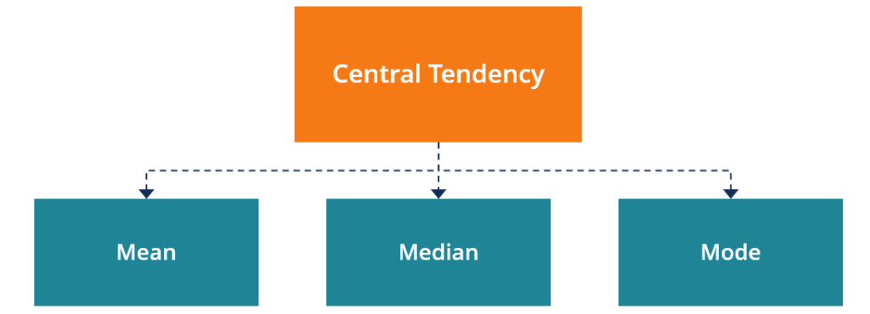

Measures of Central Tendency

Generally, the central tendency of a dataset can be described using the following measures:

**Mean (Average):**Represents the sum of all values in a dataset divided by the total number of the values.

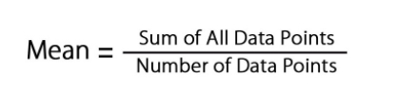

**Median:**The middle value in a dataset that is arranged in ascending order (from the smallest value to the largest value). If a dataset contains an even number of values, the median of the dataset is the mean of the two middle values.

**Mode:**Defines the most frequently occurring value in a dataset. In some cases, a dataset may contain multiple modes while some datasets may not have any mode at all.

## Standard Deviation

Difference from central value (Mean). It Could be plus, minus or zero

## Variance

Square of Standard Deviation, in order to make the Value Positve.